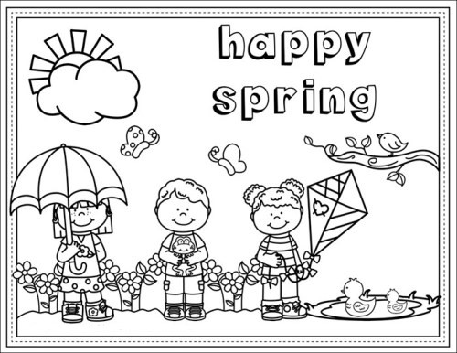
KIDS up to 10yrs
NAME:
AGE:
PHONE#

